Census Blocks Funded by Final Alternative Connect America Cost Model
Working with the Census Block List
When the list of census blocks funded by the final Alternative Connect America Cost Model (https://www.fcc.gov/general/rate-return-resources#model) is downloaded and opened directly in Microsoft Excel by double-clicking the filename, the Census Block ID (CBFIPS) may appear as scientific notation rather than a text field (1.0100102e+11 rather than 010010201001). This issue is due to Excel treating data as “general” format. The preferred method for opening the census block list is to import it in Excel as a “text” format. The step-by-step process for importing the census block list is described below.

Step One: Save and download the List of Census Blocks Funded by Final Alternative Connect America Cost Model

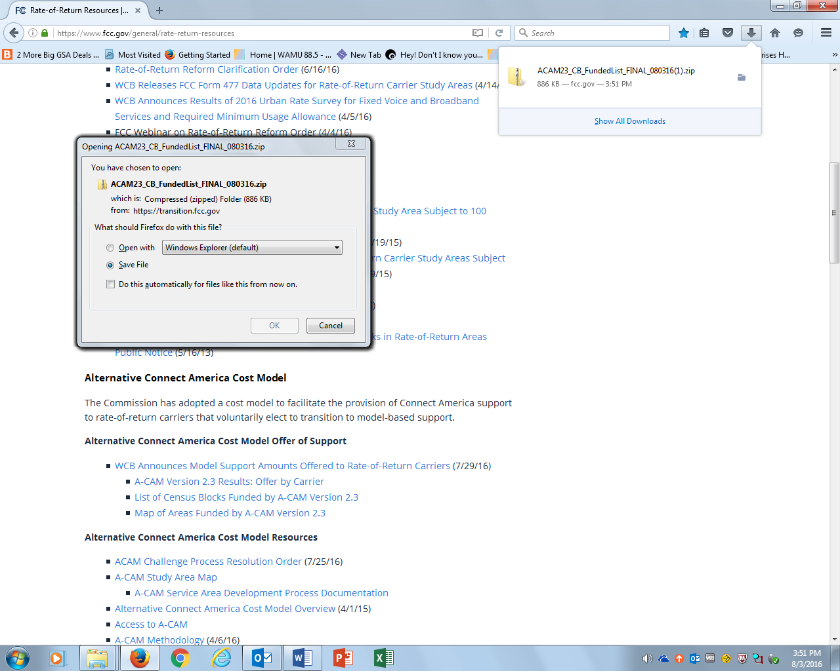

Step Two: Unzip ACAM23_CBFundedlist_Final 080316.zip

Step Three: Open Excel and Click on the Data Tab
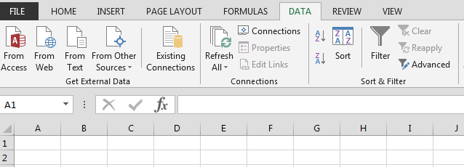

Step Four: Select “From Text”

Step Five: Import the Census Block List

Step Six: Follow the Text Import Wizard
In step one, select “Delimited” under the file type.
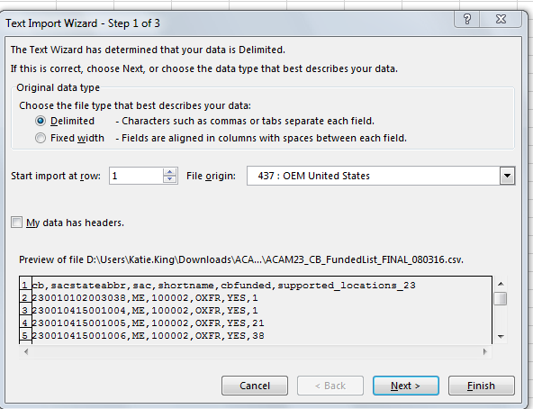

In step two, select “Comma” as the Delimiter.

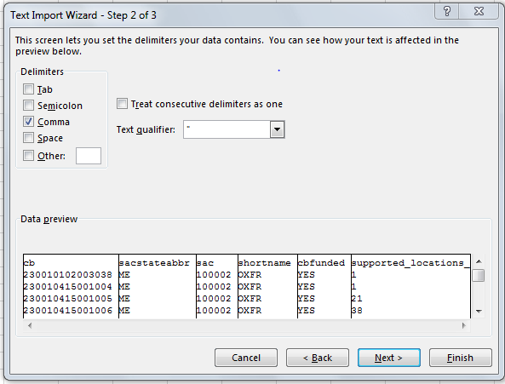

In step three, highlight the CB column, select “Text” as the Column data format, and click Finish.
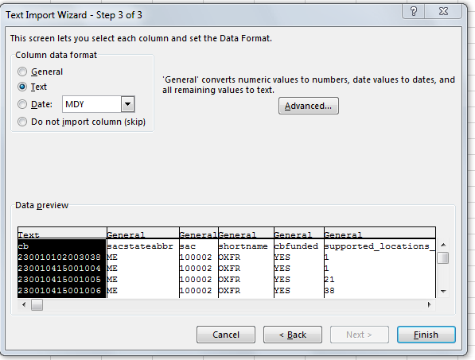

Select how you want to view data.
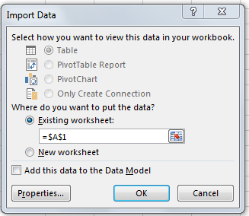

Step Seven: The census block list is formatted properly
